

Credit Card Fraud Modeling and Deployment

**Interim Report**

Higher Diploma in Science in Data Analytics

Word Count: 1500

Author: Ciaran Finnegan / 10524150

E-mail: [10524150@mydbs.ie](mailto:10524150@mydbs.ie) / [ciaran@feefinnegan.com](mailto:ciaran@feefinnegan.com)

Supervisor: Dr Shahram Azizi Sazi

Report Submission Date: 14th October 2020

**Acknowledgments**

A brief paragraph or two acknowledging professional advice and help in submitting the report.

# Contents

Contents 2

1. Introduction 3

2. Background 4

3. Requirements: Specification and Design 5

4. Project Testing an Evaluation 6

5. Demonstration of Progress 7

6. Future Work 0

7. Appendices 1

8. References / Bibliography 2

# Introduction

The introduction provides the reader with an overview of the project.

A good introduction will inform the reader what the project is about without assuming any specialist knowledge and without detail that may obscure the overview. The reader is assumed to be knowledgeable but not necessarily an expert in the field of the project.

The introduction should anticipate and combine main points described in more detail in the rest of the report.

The Introduction contains:

• the aims of the project;

• the scope of the project;

• the approach used in carrying out the project;

• assumptions, if any, on which the work is based.

Strengthen the aim/objective -

# Background

The purpose of the background is to provide the reader with the information that they may not know but which they will need in order to fully understand and appreciate the rest of the report.

The following is an indicative list of items that should be included in the background section:

* + the context of the project;
  + the anticipated benefits of the system; typical users of the project product;
  + any theory associated with the project;
  + the analytics methods/theories/algorithms used; any relevant/similar existing software/hardware

# Requirements: Specification and Design

The requirements specification must include the following:

Project/Business requirements

* What is the business/project need or problem? What business questions
* do we need to answer?
* Information requirements
* What data is necessary to answer those questions? Functional requirements
* How do we need to use the resulting information to answer those questions? Detailed report / usage req.
* Detailed layout etc. Other requirements
* All other non-functional requirements, etc.

The Design should include the high level design to meet the requirements.

In brief:

* Requirements Specification
* Design: The top-level details to meet the specification.
* Tools and Techniques: Evaluation and research to apply theories, models,
* methodologies and tools for the data analytics project.
* Use of diagrams, such as entity-relationship and UML diagrams

Strengthen – project objective Machine learning application…

Review ML papers for research… and related works…Chapter 2…

Refer to the paper and which model is best for CC classification…

Chapter 3…methodology on ML approach – which algorithm…and why picked them…

Add..Data understanding…CRISP-DM..framework and decision making process..

Read up on Fraud classification – find papers…

Look at Boosting methods…to select the most accurate model…

# Project Testing an Evaluation

It may include product verification according to the spec and unit testing, etc. Any weaknesses should be discussed.

A review of status of the project in terms of the proposed goals and project plan.

# Demonstration of Progress

Ability to illustrate and demonstrate how the artefact will work and key features it will have.

(This has to be done by means of slides, screenshots, mock--‐up, diagrams, models, sample code, prototype of working software, etc. )

**DBS Data Analytics Project Plan 2020 (Produced using the Team Gantt online portal)7**

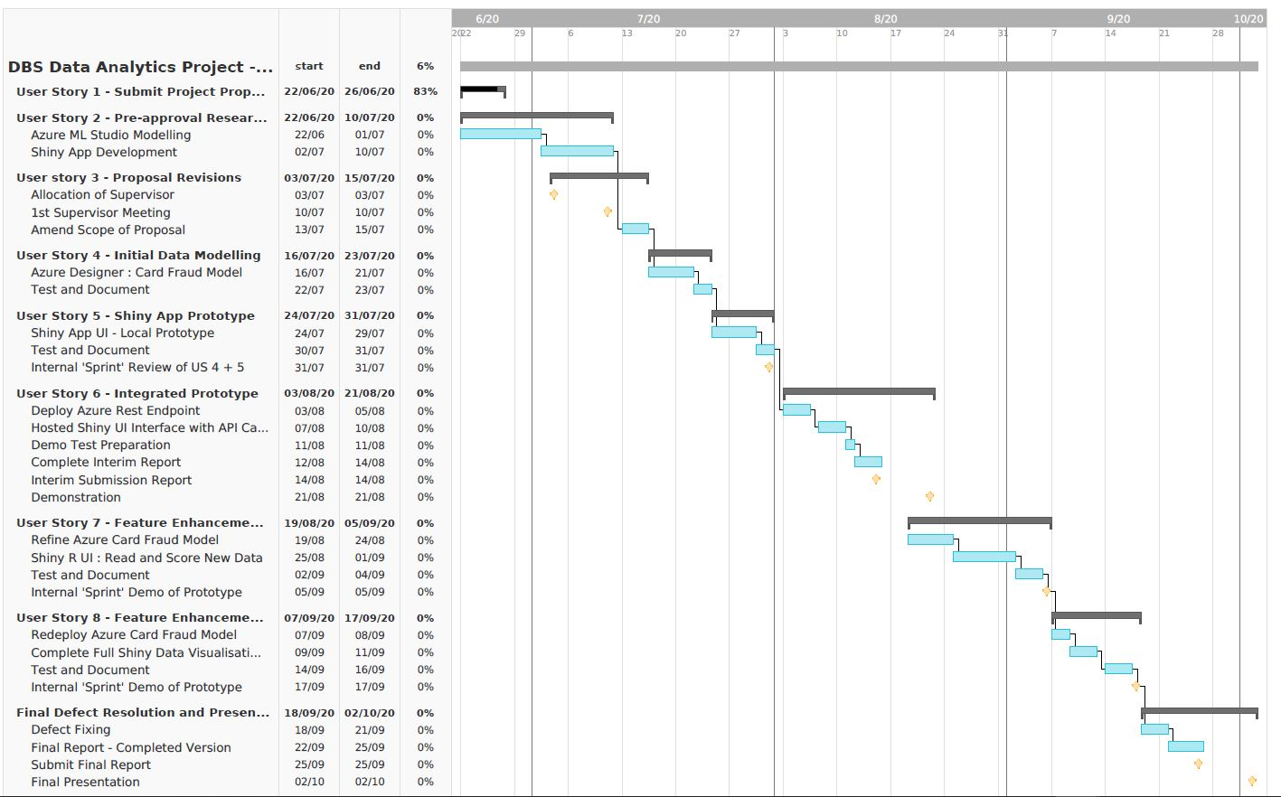

# Future Work

Suggestions on refinements or changes in direction from original project proposal should be made here. These must be justified.

# Appendices

Any code, specifications which should be included in the report should be included in appendices. User manual can also be included here.

# References / Bibliography

1. Microsoft Online Documentation (2020), ‘Tutorial: Predict automobile price with the designer (preview)’. Available at:

<https://docs.microsoft.com/en-gb/azure/machine-learning/tutorial-designer-automobile-price-train-score>

(Accessed 4 June 2020)

1. Dominik Krzeminski (June 2018) ‘Create outstanding R Shiny dashboards with the semantic.dashboard package’. Available at:

<https://appsilon.com/create-outstanding-dashboards-with-the-new-semantic-dashboard-package/>

(Accessed 1 June 2020).

1. Andy Kipp (May 2017), ‘Shinyapps.io – Getting started’. Available at:

<https://shiny.rstudio.com/articles/shinyapps.html>

(Accessed 16 June 2020)

1. Filip Stachura (December 2016) ‘We Have Created a Package to Improve the UI of Shiny Dashboards’. Available at:

<https://appsilon.com/why-have-we-created-package-to-improve-shiny-apps-user-interface/>

(Accessed 23 June 2020)

1. Tim Warner (December 2019). ‘Microsoft Azure AI Engineer: Developing ML Pipelines in Microsoft Azure’. Available at:

<https://app.pluralsight.com/library/courses/microsoft-azure-developing-ml-pipelines/table-of-contents>

(Accessed 10 June 2020)

1. ‘Wikipedia: Agile software development’ (no date). Available at:

<https://en.wikipedia.org/wiki/Agile_software_development>

(Accessed 1 June 2020)

1. ‘Welcome to TeamGantt’ (no date). Available at:

<https://support.teamgantt.com/article/77-welcome-to-teamgantt/>

(Accessed 17 June 2020)